**JQuery is an open source JavaScript library that simplifies the interactions between an HTML/CSS document, or Document Object Model (DOM), and JavaScript.**

HTML manipulation, DOM manipulation, DOM element selection, CSS manipulation, Effects and Animations, Utilities, **AJAX**,HTML event methods, JSON Parsing, Extensibility through plug-ins

**JQueryHTML doesn’t work with XML document**. It only works for HTML documents.

jQuery is developed by Google.

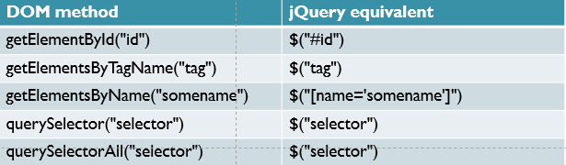

**Select elements by class Example: $(“.xyzclass”)**

**$(document).ready() and $()**

The code inserted between $(document).ready() is executed only once when page is ready for JavaScript code to execute.

In place of $(document).ready(), you can use shorthand notation $() only.

1.

$(document).ready(function() {

$("p").css("color", "red");

});

The above code is equivalent to this code.

2.

$(function() {

$("p").css("color", "red");

});

You can use any number of document.ready() function on the same page.

Jquery Effect:

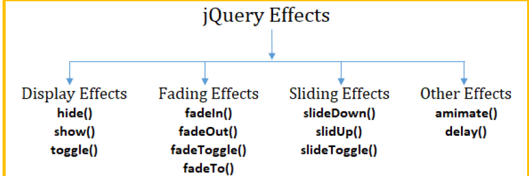

jQuery fadeToggle() method is used to toggle between the fadeIn() and fadeOut() methods. If the elements are faded in, it will make them faded out and if they are faded out it will make them faded in.

jQuery fadeTo() method is used to fading to a given opacity.

**Selector**

jQuery Selectors are used to select and manipulate HTML elements.

All jQuery selectors start with a dollor sign and parenthesis e.g. $(). It is known as the **factory** **function**.

**Difference between find and children methods ?**  
The [**find()**](https://www.geeksforgeeks.org/jquery-find-with-examples/) method is used to find all the descendant elements of the selected element and the [**children()**](https://www.geeksforgeeks.org/jquery-children-with-examples/) method is used to find all the children element related to that selected element.

Remove(data+chils+element),empty.detach

# **jQuery remove()**

 It removes the selected element itself, as well as everything inside it (including all texts and child nodes).

empty()The jQuery empty() method is used to remove all child nodes and content from the selected elements. **This method doesn't remove the element itself.**

.detach() method doesn’t remove jQuery data associated with the matched elements.

#### **If you want to remove elements without removing data and events, you should use the detach() method. If you want to remove only data and events, use the empty() method.**

**The jQuery serialize() method is used to create a text string in standard URL-encoded notation.**